Mental Health and Stress Relief

Mental health, defined by the World Health Organization, is "a state of well-being in which the individual realizes his or her own abilities, can cope with the normal stresses of life, can work productively and fruitfully, and is able to make a contribution to his or her community"

Tips to tame stress
Stress relievers can help restore calm and serenity to your chaotic life. You don't have to invest a lot of time or thought into stress relievers. Here are some helpful examples of what to you can do.

Get active
Virtually any form of physical activity can act as a stress reliever. Physical activity can pump up your feel-good endorphins and other natural neural chemicals that enhance your sense of well-being. Exercise can also refocus your mind on your body's movements, which can improve your mood and help the day's irritations fade away. Consider standing up at your desk, figure 4 stretches, the squat song (Flower by Moby) and/or plank songs.

Eat a healthy diet
Eating a healthy diet is an important part of taking care of yourself. Aim to eat a variety of fruits and vegetables, lots of protein and whole grains. It is also important to make sure you are drinking lots of water, taking vitamin D with Vitamin K to help the absorption of it and vitamin C and selenium to keep your immune systems up. What you put into your body is what you will get out of it. A stash of snacks is an important part of that healthy diet. You never know when a fire will pop or how quickly it will grow. Leaving for lunch or dinner isn’t always an option. If you have been around toddlers before they have had their afternoon snack you know what a hangry person can turn into.

Meditate
During meditation, you focus your attention and quiet the stream of jumbled thoughts that may be crowding your mind and causing stress. Meditation can instill a sense of calm, peace and balance that can benefit both your emotional well-being and your overall health.
Guided meditation, guided imagery, visualization and other forms of meditation can be practiced anywhere at any time. Youtube, Insight Timer, Headspace and Calm are examples of free apps that you can use. A short deep breathing exercise called 4-square or box breathing may help to clear your mind, relax your body and improve focus. Take a 2 to 5 minute eyes closed break while taking deep belly breaths in through your nose counting slowly to 4, hold at the top up to a 4 count, breathe out counting slowly to 4 and holding at the bottom up to a 4 count, rinse and repeat at least 4 times.

Laughter
A good sense of humor can't cure all ailments, but it can help you feel better, even if you have to force a fake laugh through your grumpiness. When you laugh, it not only lightens your mental load but also causes positive physical changes in your body. Laughter fires up and then cools down your stress response. So read some jokes, tell some jokes, watch a comedy or hang out with your funny friends. Or give laughter yoga a try.

Connect with others
When your stressed and irritable, your instinct may be to isolate yourself. Instead, reach out to family and friends and make social connections. Especially as we move towards more isolated workspaces from home and less human interaction as we continue to maneuver the changes COVID has caused in this last year and future policy, it is important to have connection.
Social contact is a good stress reliever because it can offer distraction, provide support and help you tolerate fire season’s up and downs. So take a coffee break with a friend, email a relative or go on a walk while you zoom with a fellow fire friend in a different part of the country so you can remember there are others working hard along with you.

Assert yourself
You might want to do it all, but you can't, at least not without paying a price. Learning to say no or being willing to delegate can help you manage your to-do list and your stress.
Saying yes may seem like an easy way to keep the peace, prevent conflicts and get the job done right. But it may actually cause you internal conflict because your needs for your health and mental stability are being put on the back burner, which can lead to stress, anger, resentment and a need for revenge. I know it seems silly to say this but if you are operating from stress you are operating from fight, flight or freeze mode.

Try yoga
With its series of postures and controlled-breathing exercises, yoga is a popular stress reliever. Yoga brings together physical and mental disciplines which may help you achieve peacefulness of body and mind. Yoga can help you relax and manage stress and anxiety. There are many online options. PT is a wonderful thing to make sure to do throughout your workdays and often running or weight training are the go-to exercises. Consider mixing it up and add yoga into the mix for a different strength training, flexibility and stress relieving work out.

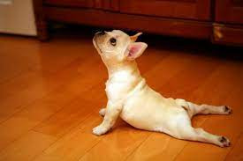

Get enough sleep
Stress can cause you to have trouble falling asleep. When you have too much to do — and too much to think about — your sleep can suffer. But sleep is the time when your brain and body recharge.
And the quality and amount of sleep you get can affect your mood, energy level, concentration and overall functioning. If you have sleep troubles, make sure that you have a quiet, relaxing bedtime routine, listen to soothing music, put clocks away, and stick to a consistent schedule. I know, on a fire assignment in a different place or after a 16 hour work day the last thing you want to do or have time for is your journaling about your day, 15 minute meditation, face and eye mask, make sure your food is made and ready for the next few days or whatever it is that winds you down to get the best REM sleep possible. Check in with yourself and with your fellow coworkers and managers. Sometimes a 20 minute nap at lunch in a quiet space or in the car, maybe taking turns with the late shift to make sure everyone is balancing enough sleep. Whatever the needs are communication is key. You know best how you are feeling and if your sleep deprivation is getting to be too much LET SOMEONE KNOW!

ALTERNATIVE OPTIONS

- Essential Oils: Lavender, Bergamot, Frankincense, Geranium, Grapefruit- you can either touch them to reflexology points, temples forehead, diffuse them (in your own space) or just take a deep inhale of one of these. It is important to get all of your senses enjoying a break from stress.
- Walking meditation: a slow intentional walk around a park, hug a tree, ground yourself barefoot in the grass
- Blue light glasses
- Acupressure Points: I have included some classics
- Journaling: If you get your day out on paper, it won’t swirl around in your mind all night keeping you from deep, restorative sleep.
- Color Therapy: wear bright colors on grey days
- Sound therapy: tuning forks or your favorite songs

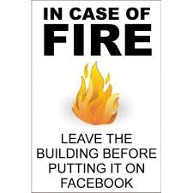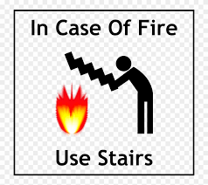

References: Mayo Clinic

ACUPRESSURE POINT SELECTION FOR STRESS AND ANXIETY RELIEF:

Applying pressure to acupuncture points mobilizes energy in the channels and communicates with the nervous system to stimulate the release of those feel-good chemicals. In Chinese Medicine theory, emotions and mental functions are viewed as components of qi (the body’s vital energy) and blood. Correcting the movement of qi and blood in the meridians brings balance back to the mind, body, and spirit.
Most acupuncture points calm the nervous system, but here are a few favorites for reducing stress and easing anxiety: Du 20, Yin Tang, Ren 17, GB-21, Ht-7, Sp-6, and Lr-3.
In Chinese Medicine, all emotions have a special directionality. The “qi” of anxiety and stress is generally concentrated upwards, settling into the mind, shoulders, heart, and chest. Acupressure can help redistribute this energy through the meridians so you can ground again.
To do this, we recommend starting with Du-20, the point at the top of your head, and ending with Lr-3 on the feet for a grounding treatment. You can press the point on each side of the body to feel which one is more tender/sensitive. If you notice a difference, spend more time on the tender side. If you’re still feeling unsettled, press into the bottom of your feet, which your thumb or a tennis ball, to anchor that energy.
When locating points, feel for a tender spot or a place when your finger seems to dip slightly. Most acupuncture points are noticeable once you find them! Spend 30 seconds on each point with firm pressure, while taking nice deep breaths into your abdomen.
Tip: Try using relaxing essential oils like lavender, neroli, clary sage, sandalwood, bergamot, or vetiver to enhance your acupressure session.

GOVERNING VESSEL 20 (DU-20) “HUNDRED MEETINGS”
Location: located at the crown of the head. Place a finger at the top of each ear and follow an imaginary line upward- Du-20 is located where your two fingers meet.
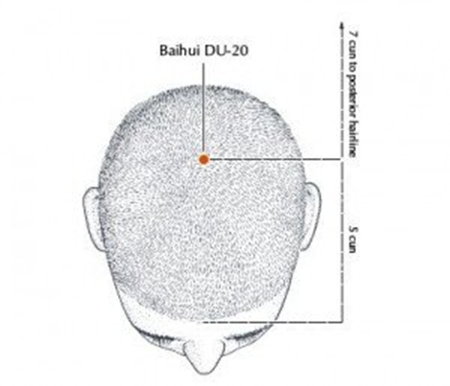
Actions: regulates the movement of all yang energy in the body. Pressing on this point can both raise the yang to lift depression and sadness, and, it can ground energy to ease anxiety and overthinking. Du-20 clears the mind to help you feel focused and present. As a “Sea of Marrow” point, Du-20 nourishes the brain and can help treat headaches, dizziness, insomnia, and other neurological conditions.

YIN TANG “HALL OF IMPRESSION”
Location: located between the eyebrows, in the area known as the third eye
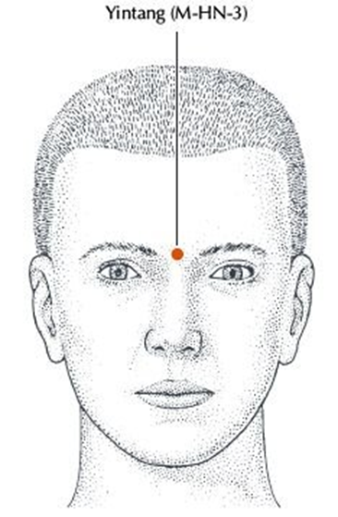
Actions: powerfully calms the spirit and takes the edge off emotional restlessness and anxiety. Connects with the pineal gland to promote deep relaxation and treat insomnia; relieves headaches, foggy thinking, and helps clear nasal congestion or a runny nose. A favorite point to include in any acupuncture treatment for emotional well-being.

GALL BLADDER 21 (GB-21) “SHOULDER WELL”
Location: at the highest point of the shoulder (in the muscle), at the midpoint between the spine and the rotator cuff
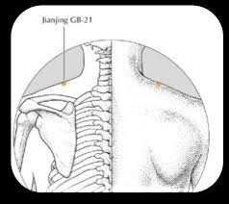
Actions: a go-to area for massage, pressing into GB-21 strongly descends energy to release stress and tension held in the upper body, and, can help alleviate anger, migraines, and high blood pressure. Also helpful for those who feel you “carry the burden of the world on your shoulders”. As you press on this point, be sure you maintain steady breaths into your abdomen. Note: Do not use if pregnant.

CONCEPTION VESSEL 17 (REN 17) “CHEST CENTER”
Location: At the center of the chest, midway between the nipples.
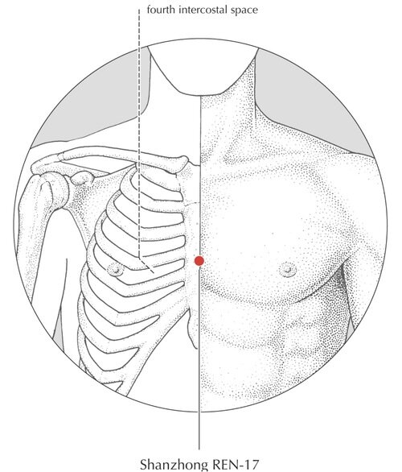
Actions: beneficial for those who tend to feel the effects of stress and anxiety in their chest, manifesting as shortness of breath, tightness, or palpitations. Relaxes and opens the chest and releases the diaphragm. Known as the 'influential point of Qi', this is an essential point to regulate the movement of qi, which often becomes stuck with emotional distress.

HEART 7 (HT-7) “SPIRIT GATE”
Location: on the inner wrist crease, towards the ulnar (little finger) side. Feel for a hollow at the base of the pisiform bone.
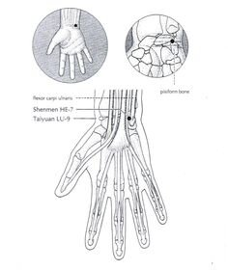
Actions: the “source point” on the heart channel, where the vital energy of the heart organ system gathers. Deeply connects with the heart meridian to nourish the spirit and treat all emotional imbalances and strengthen heart qi and blood. Quiets the mind and settles worry/anxiety; eases emotional distress with sleep disturbances; releases chest tightness and heart palpitations; strengthens the Fire element- animation, joy, and connection; used in the treatment of emotional shock.

SPLEEN 6 (SP-6) “THREE YIN CROSSING”
Location: on the inside of your leg, just above your ankle. To find this point, (1) locate the highest peak of the ankle then (2) four finger widths up your leg, slightly behind the bone (tibia)
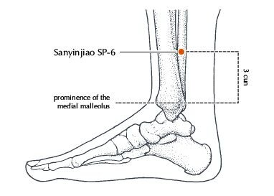
Actions: one of the best points for digestive, gynecological, and urinary issues, as well as emotional and sleep disorders. Named “3 yin crossing” because the liver and kidney meridians pass here- three organ systems that become easily taxed during times of stress. This can feel like exhaustion/fatigue, chronic pain, indigestion, and period problems. Sp-6 builds back blood and yin and moves stagnant energy in these channels. Note: Do not use if pregnant.

LIVER 3 (LR-3) “GREAT SURGE”
Location: located on the foot, between the first and second toes, about an inch away from the web of the toes
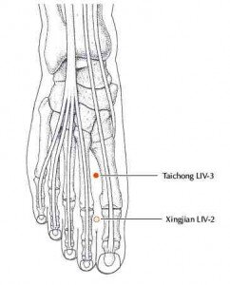
Actions: THE point to relieve anger, stress, and irritability. Regulates the flow of qi and blood everywhere in the body to release tension and treat pain. An important point to treat menstrual and digestive conditions worsened by stress, as well as headaches and TMJ. The source point of the Liver meridian system, LR-3 nourishes Liver yin and blood and calms the spirit. Detoxifying and cleansing for the liver.
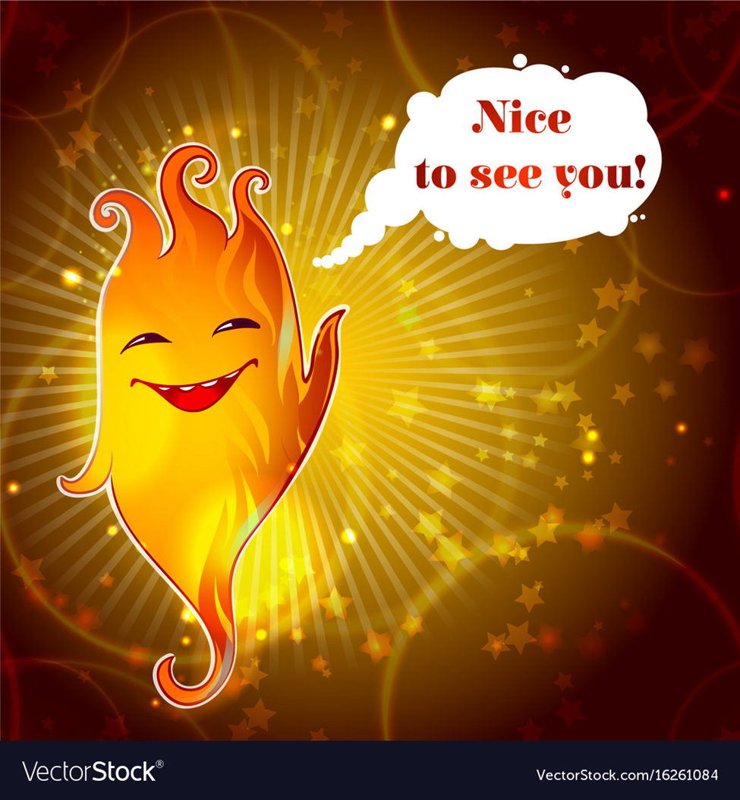
References
Deadman, Peter. A Manual of Acupuncture (2007), Balance Acupuncture

